Assessment Schedule – 2015

Science: Demonstrate understanding of aspects of mechanics (90940)

Evidence Statement
Question | Evidence |  |  | Achievement |  | Achievement with Merit |  | Achievement with Excellence
ONE  (a) | 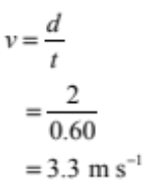 |  |  | Correctly calculates the speed.
(b) | F = m × g  = 48 × 10  = 480 N  W = F × d  = 480 × 2  = 960 J  OR  E_{p} = mgh  = 48 × 10 × 2  = 960 J |  |  | Calculates the weight force as  480 N. |  | Calculates work as 960 J.
(c) | Work is proportional to the force applied (weight force) and the distance travelled.  OR W = F × d (formula or words)  OR work is needed to transfer energy, as Ian has more mass and weight, he also climbs longer distance, more energy transferred therefore more work done.  Ian completes a greater amount of work because he had a mass of  52 kg, compared with Chris with a mass of 48 kg  Ian climbs a greater distance, 5 m, compared with Chris, who climbed only 2 m |  |  | States Ian does largest work with a supporting reason. |  | Explains relationship between mass (weight force), distance and work.
(d) | Ian had gained gravitational potential energy at the top of the diving board and this was converted into kinetic energy.  We assume that all gravitational potential energy will equal the kinetic energy.  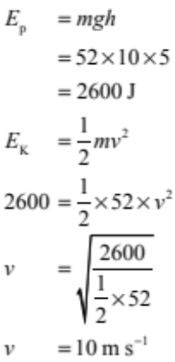 OR 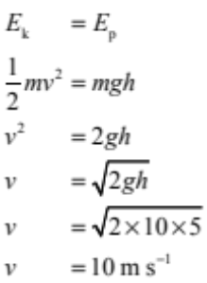 |  |  | Uses the correct formula to calculate gravitational potential energy but makes mathematical error.  OR 10ms⁻¹ without no working  Recognises conservation of energy is obeyed.  Correctly names the two energies for given locations. |  | Calculates correct gravitational potential energy and includes unit. |  | Calculates the speed correctly, with unit (one minor error).
(e) | There are some losses of energy due to friction / air resistance. This means that some of the initial gravitational potential energy is converted into heat and sound as well as kinetic energy. As a consequence, the kinetic energy is less than that calculated (theoretical value), and the boy enters the water at a slower speed. Air resistance / friction occurs as the boy falls, because the boy is pushing past air particles. As the air particles rub against the boy, heat and sound are generated. |  |  | Identifies that air resistance / drag / friction is the reason for the slower speed. |  | Explains that air resistance / friction causes energy losses / transfers to heat/sound. |  | Explains that air resistance / friction causes losses of energy AND the energy is converted into heat and / or sound AND that, as the kinetic energy (energy of motion) is less, the boy enters the water at a slower speed.  (Missing reference to air particles OR missing the kinetic energy is less is a minor error here.)
Q1 | NØ = no response or no relevant evidence | N1 = 1 point from Achievement | N2 = 2 points from Achievement | A3 = 3 points | A4 = 4 points | M5 = 2 points | M6 = 3 points | E7 = 2 points OMI | E8 = 2 points

Question | Evidence | Achievement | Achievement with Merit | Achievement with Excellence
TWO  (a)(i)  (ii) | Weight is the downward force due to gravity that an object experiences due to its mass, while mass is a measure of the amount of matter that an object has.  OR mass is amount of matter / stuff / molecules in an object, while weight is the force due to gravity. Mass does not change when location changes while weight does; (explaining) this can be given as an example of a person on the earth or on the moon.  F_{w} = m × g  = 0.630 × 10  = 6.30 N | Defines mass and weight.  Calculates F_{w} but uses 630 g in calculation. | Explains the difference between mass and weight.  Correctly calculates F_{w}. with unit.
(b) | Net Force:  A net force is the resultant (overall/total/sum of) force on an object (when multiple forces interact). If the forces are pointing in the same direction, the forces add, giving a larger net force. If the forces are in opposite direction, the forces subtract, giving a smaller net force (including a zero net force).  Net forces determine whether the bird is accelerating, decelerating or maintaining constant speed. If the net force is pointing in the same direction as the direction of motion, the object accelerates. If the net force is pointing in the opposite direction to the direction of motion, the bird decelerates. If there is no net force, the bird maintains constant speed or is stationary.  Explanation of motion  Diagram A: The bird has constant speed, so the net (horizontal) force is zero.  Diagram B: The bird is slowing down, so is decelerating. An unbalanced force is required to make an object’s speed change, therefore, as there is an unbalanced force, the speed will decrease, and the net (horizontal) force is in the opposite direction to the motion of the bird. | Describes net force.  OR  That forces are balanced (the net force is zero) when moving at a constant speed.  OR  Forces are unbalanced (the net force is not zero) (or there is a negative net force) when slowing down. | Explains that unbalanced forces lead to a change in speed. | In diagram A (constant speed) the net horizontal force is zero. In diagram B the bird is decelerating, so forces are unbalanced, which causes decrease in speed, with the net force being in the opposite direction to the motion.  (To the right or backwards is not sufficient.)

(c)(i) | Bird B has the greater acceleration – the gradient / slope of the line is greater.  Bird A has an acceleration of:  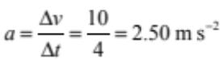  Bird B has an acceleration of:  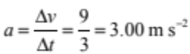 |  |  | States Bird B has greatest acceleration due to having the greatest gradient.  OR  Calculates acceleration for either bird.
(ii) | Bird A travelled:  (A) 0 – 4 s: 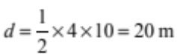  (B) 4 – 14 s: 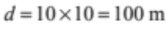  (C) 14 – 16 s: 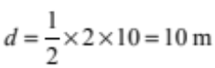  Total distance = 130 m  So Bird A has flown 8.50 m further.  (130 – 121.5 = 8.50 m) |  |  | Calculates the area / distance of section (B) as 100 m.  OR  Identifies that sections A and / or C are triangles and attempts to find the area using ½b × h or other acceptable method but makes an error in the calculation. |  | Correctly calculates the area / distance of section B (100 m) AND either section A (20 m) OR section C as 10 m.  OR  Finds the total area / distance by adding each section, but either makes an error with the addition or has made a mistake when calculating ONE section only. |  | Correctly finds the total area  130 m.  AND  Using the calculations, explains that the Bird A has flown 8.50 m further than bird B.  (Missing unit minor error)
Q2 | NØ = no response or no relevant evidence | N1 = 1 point from Achievement | N2 = 2 points from Achievement | A3 = 3 points | A4 = 4 points | M5 = 2 points | M6 = 3 points | E7 = 2 points with one minor error | E8 = 2 points

Question | Evidence |  |  | Achievement |  | Achievement with Merit |  | Achievement with Excellence
THREE  (a) | A: Acceleration / increasing speed  B: Constant speed /steady speed  C: Decelerating / decreasing speed  D: Stationary / stopped/at rest (NOT stopping or coming to a stop) |  |  | Describes 3 sections of the graph correctly.
(b)(i)  (ii) | 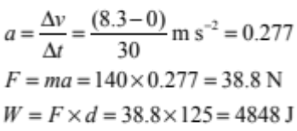  (Rounding not assessed.) |  |  | Correct calculation of acceleration.  Correct calculation of force. |  | Calculates work done.
(c) | Surface area of pontoon = 4 × 3 =12 m²  Weight of pontoon: F = m × g = 185 × 10 = 1850 N  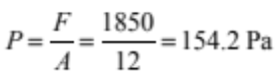 (N/m² or Nm⁻²)  Sinking into the water depends on pressure – the greater the pressure, the further the pontoon sinks.  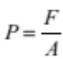  A ‘lighter’ pontoon will have less weight force than a ‘heavier’ pontoon.  In this example, the pontoon has the same area but a greater weight when the people are on it, so the pontoon sinks deeper into the water because the pressure has increased. |  |  | Calculates the area of the pontoon correctly.  OR  Calculates the weight of the pontoon correctly.  States that sinking depth depends on pressure.  States that the pontoon with people standing on has more weight force but does not link to pressure. |  | Calculates the pressure for the pontoon but uses mass instead of weight force.  Explains that the pontoon with 2 people standing on has more mass, therefore more weight force, therefore more pressure (or vice versa for the one without ). |  | Correctly calculates pressure including correct units  Compares the weight of the pontoon with and without the people to explain why the pontoon with a greater weight force sinks further into the water.  (Unit lacking minor error.)
Q3 | NØ = no response or no relevant evidence | N1 = 1 point | N2 = 2 correct points from Achievement | A3 = 3 points | A4 = 4 points | M5 = 2 points | M6 = 3 points | E7 = 2 points with minor error in one | E8 = 2 points

Cut Scores
Not Achieved | Achievement | Achievement with Merit | Achievement with Excellence
0 – 7 | 8 – 13 | 14 – 19 | 20 – 24

